AWS Task-2

**AWS Task-2**

**Task Description:**

Set up a VPC with an Internet gateway, create a public subnet with 256 IP addresses, a private subnet with 256 IP addresses, make a route table connecting the Internet gateway and the subnets, and launch a Linux EC2 instance by using the above VPC and public subnet.

**Techstacks needs to be used :**

* AWS VPC
* AWS EC2

**Created a VPC**

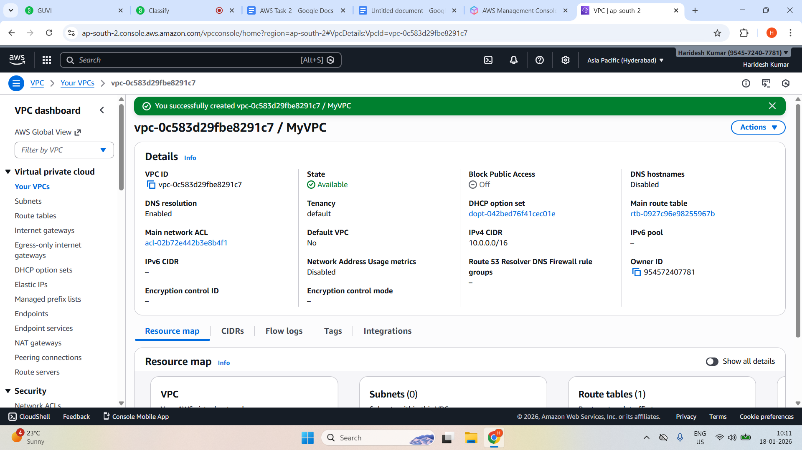

**Created an Internet gateway**

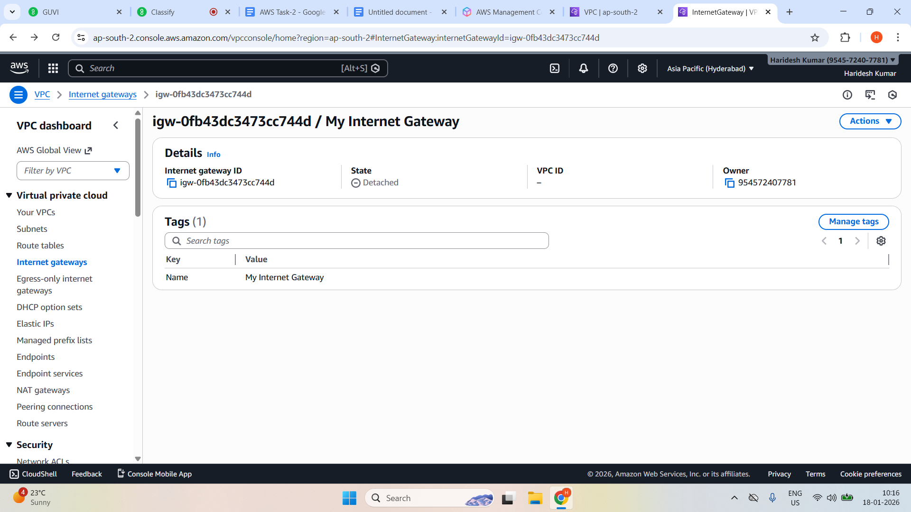

**Attach to VPC**

**Actions —---> Attach to VPC**

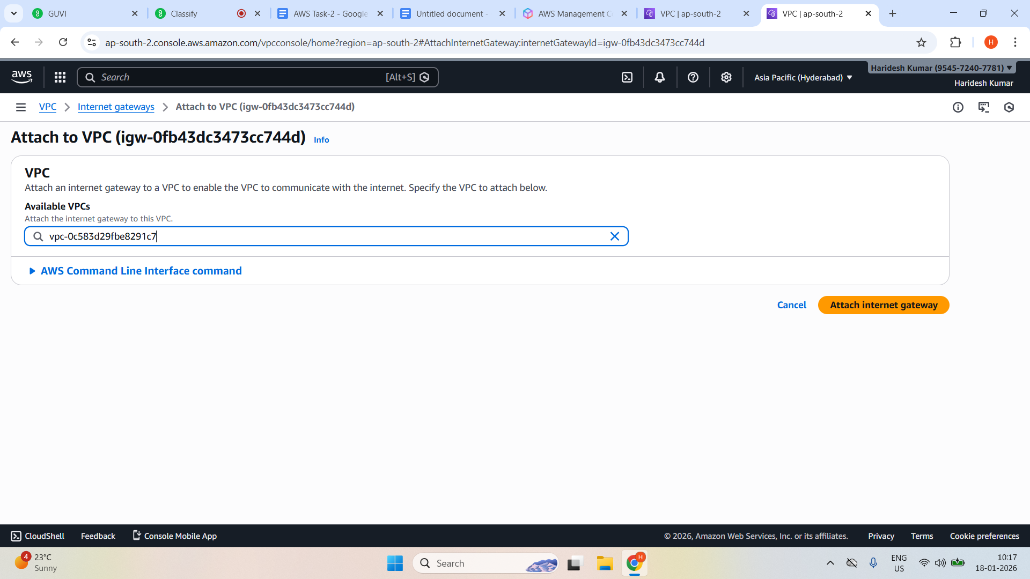

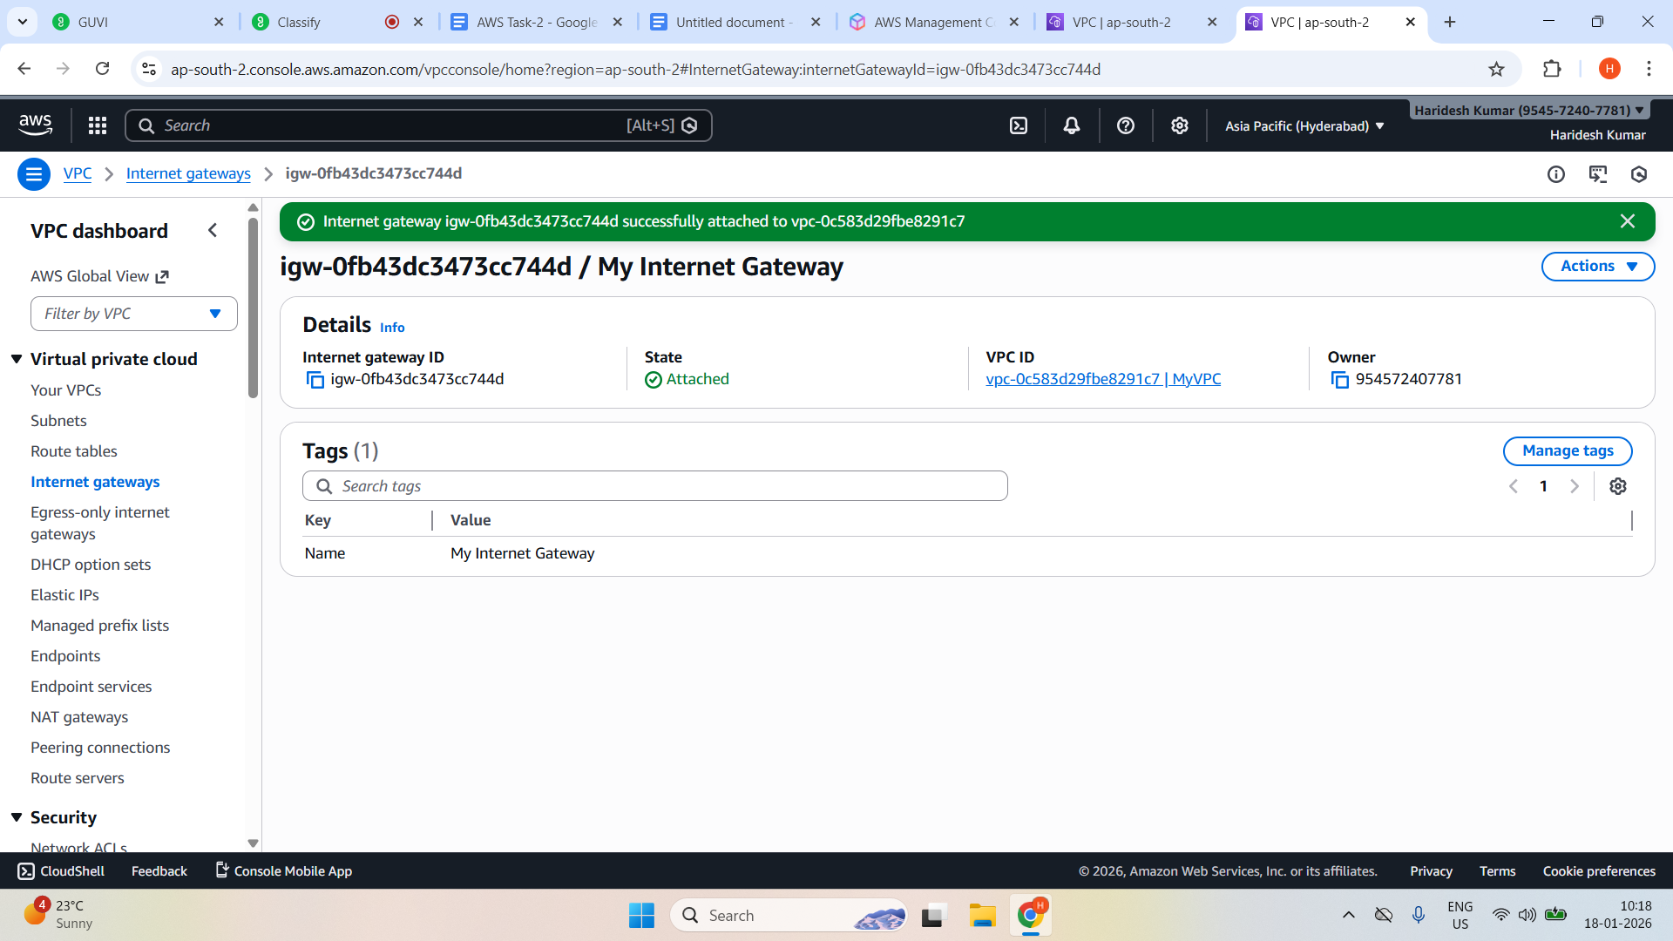

**Created a Public subnet (256 IPs)**

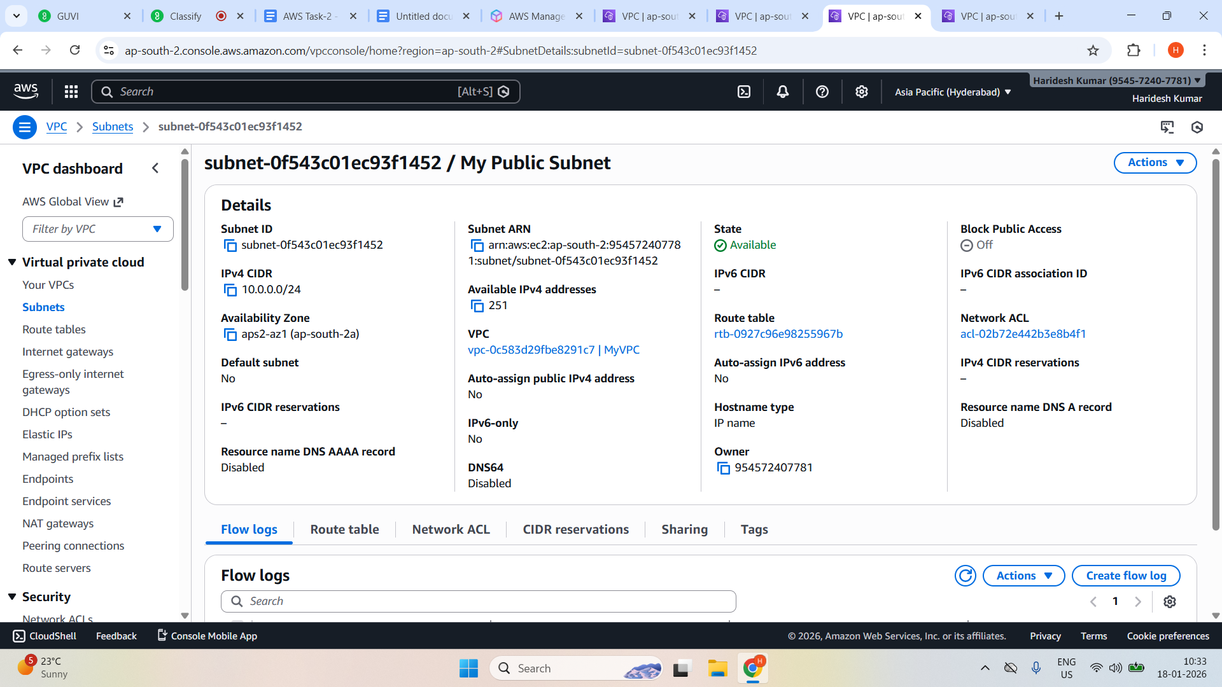

**Created a Private subnet (256 IPs)**

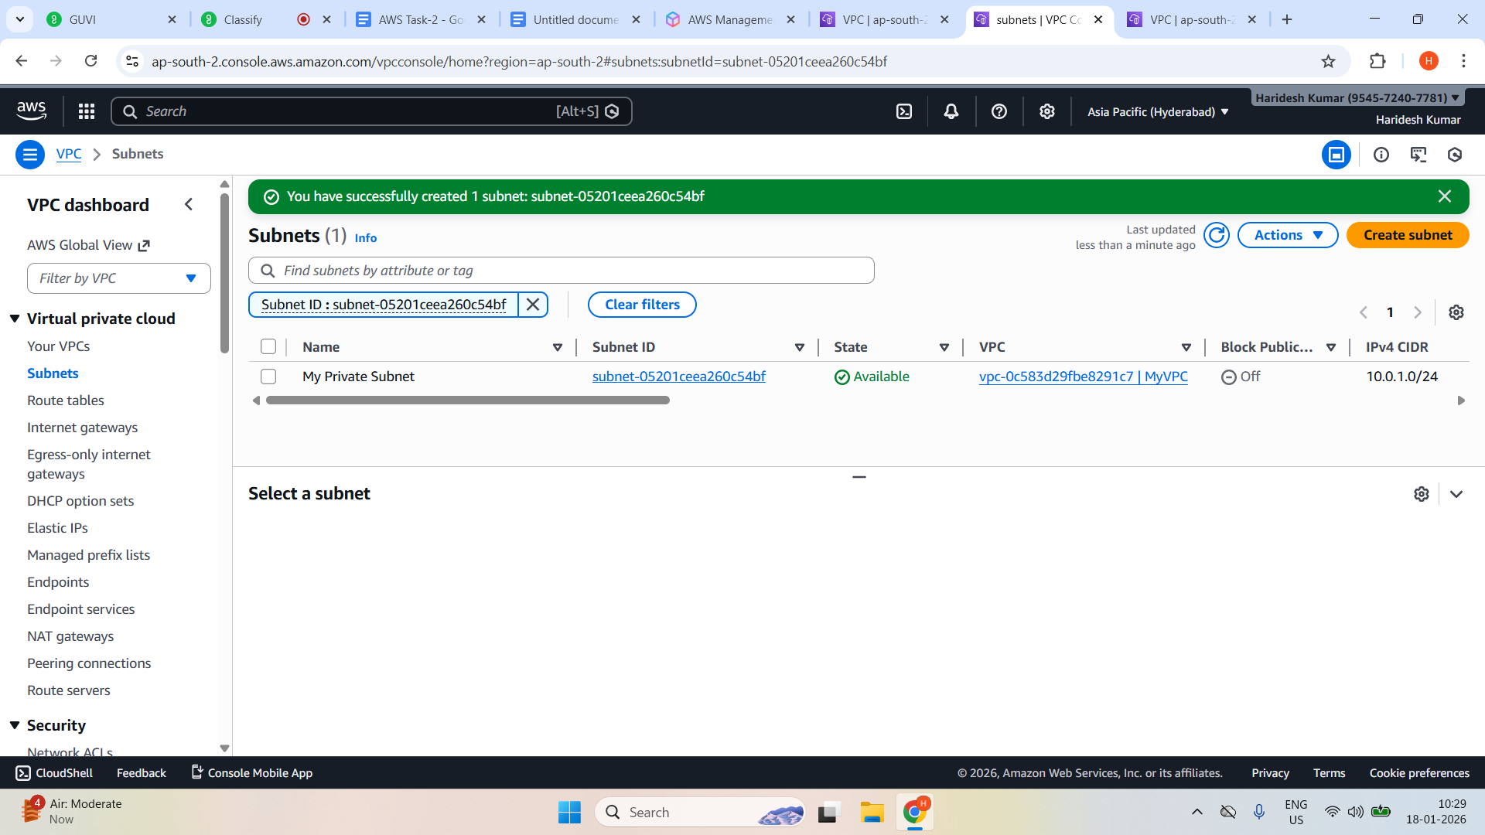

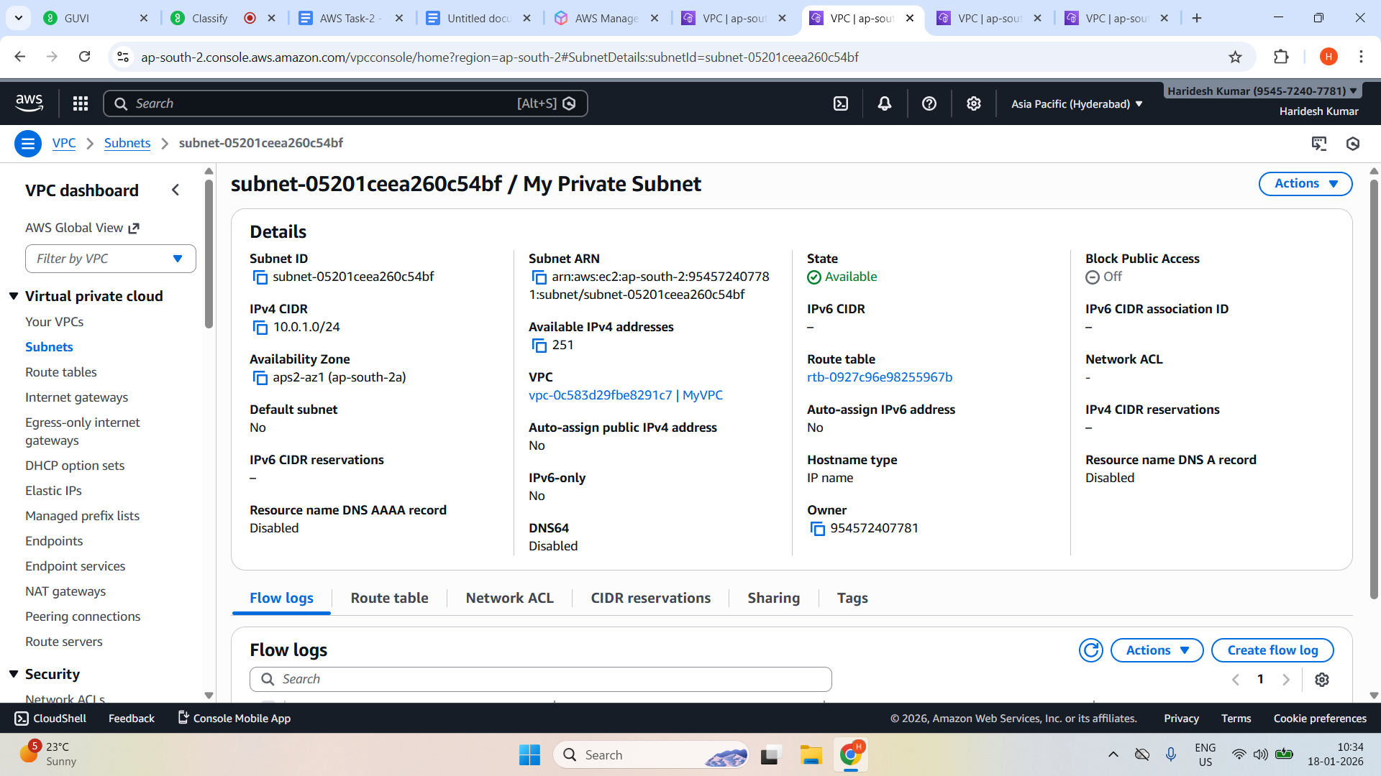

**Enable Auto-Assign Public IP for Public Subnet**

**Select Public subnet —> Actions—> Edit subnet settings**

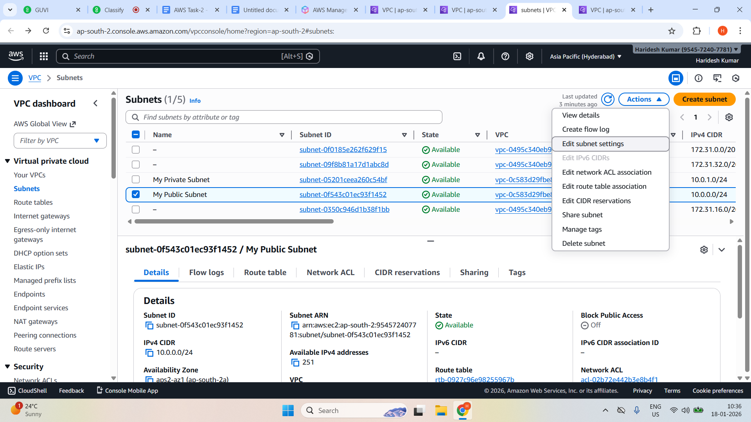

**Enable Auto-assign Public IPv4 address and click save**

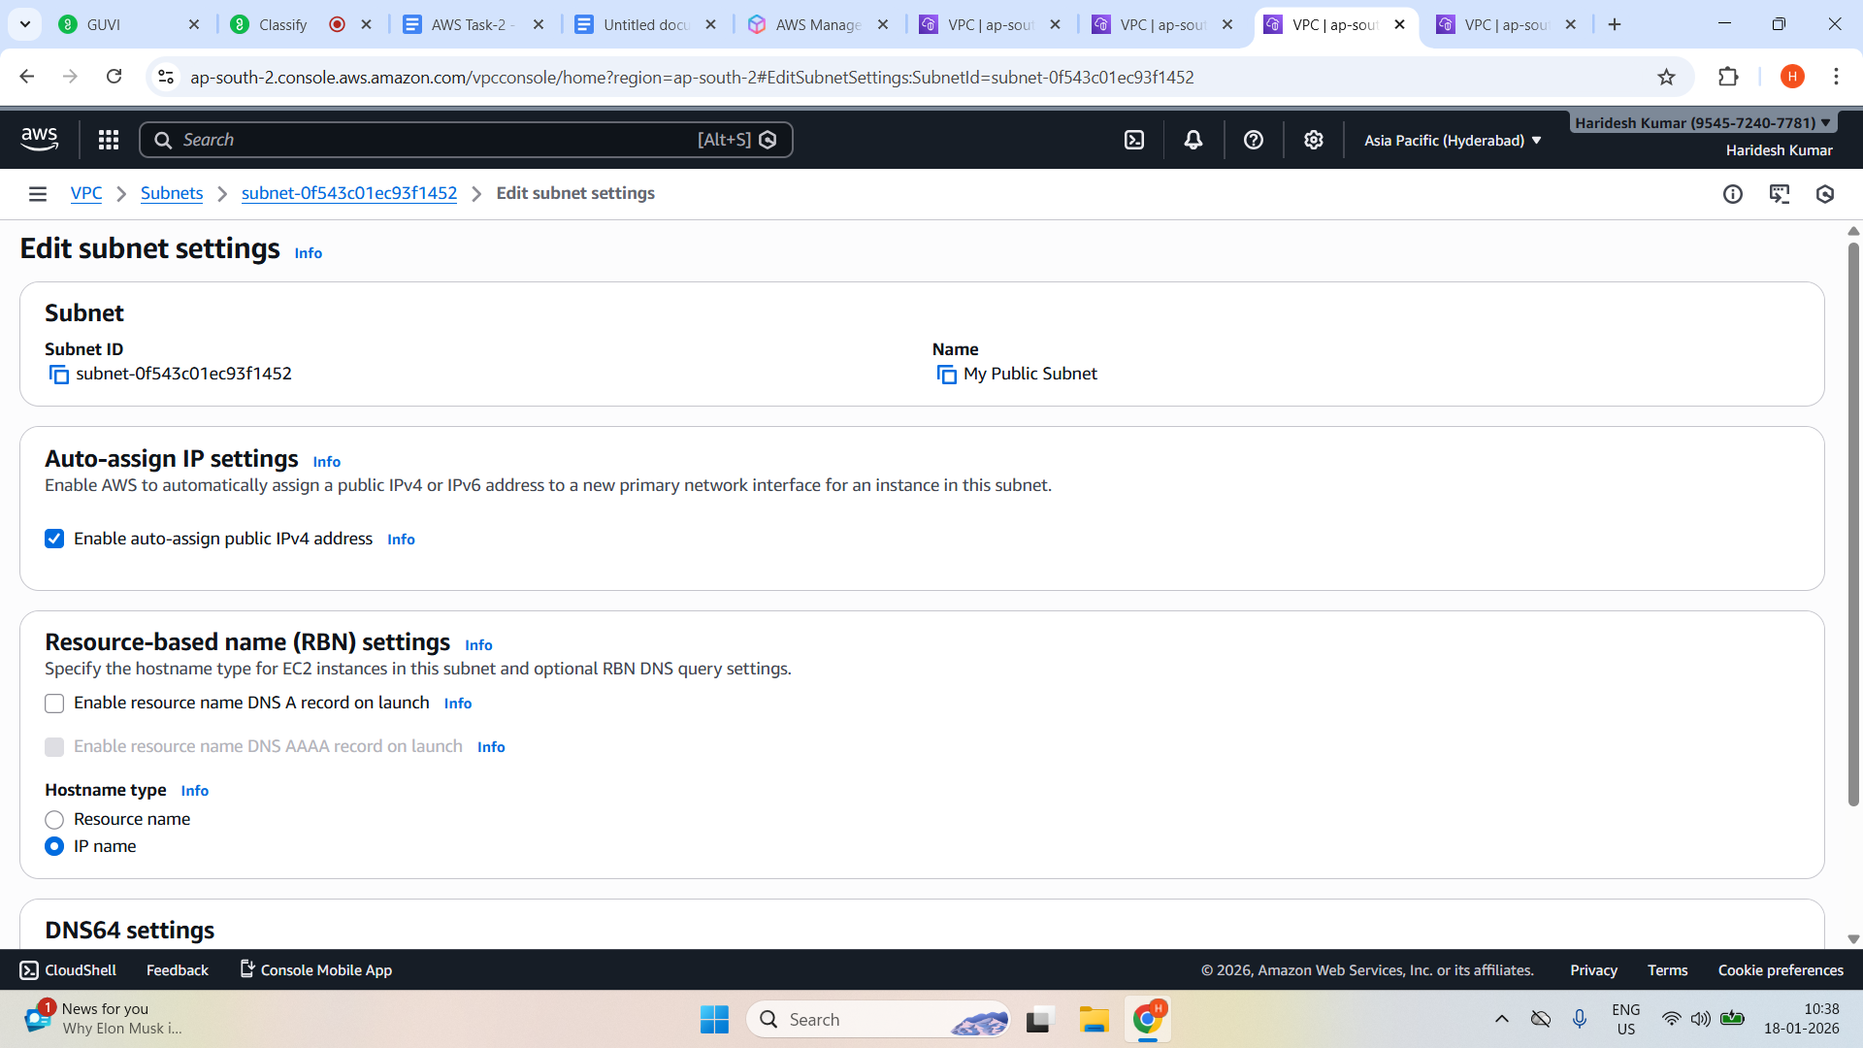

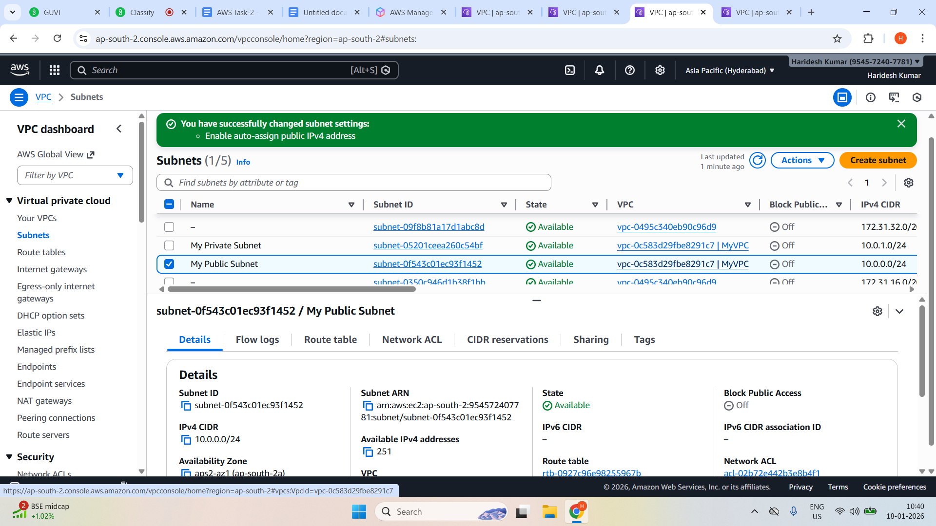

**Created a Route tables**

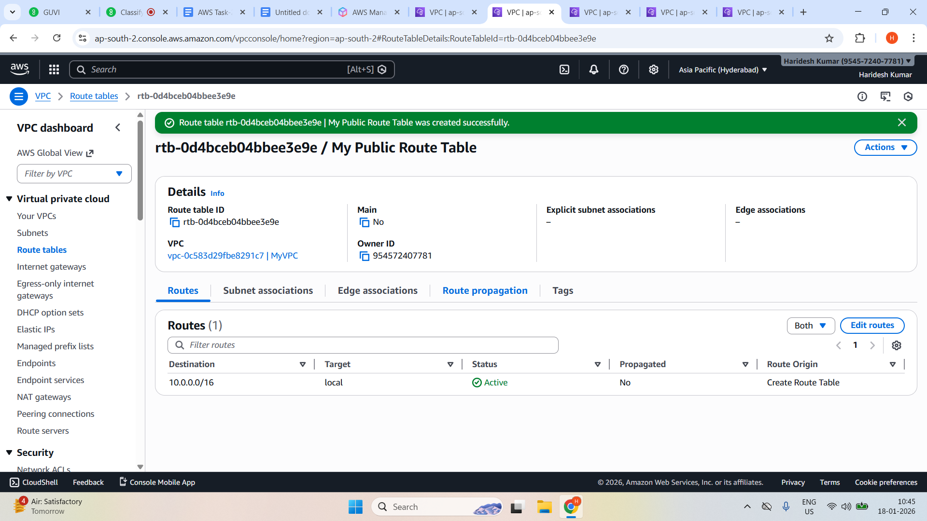

**Add Internet gateway route**

**Actions —> Edit Routes**

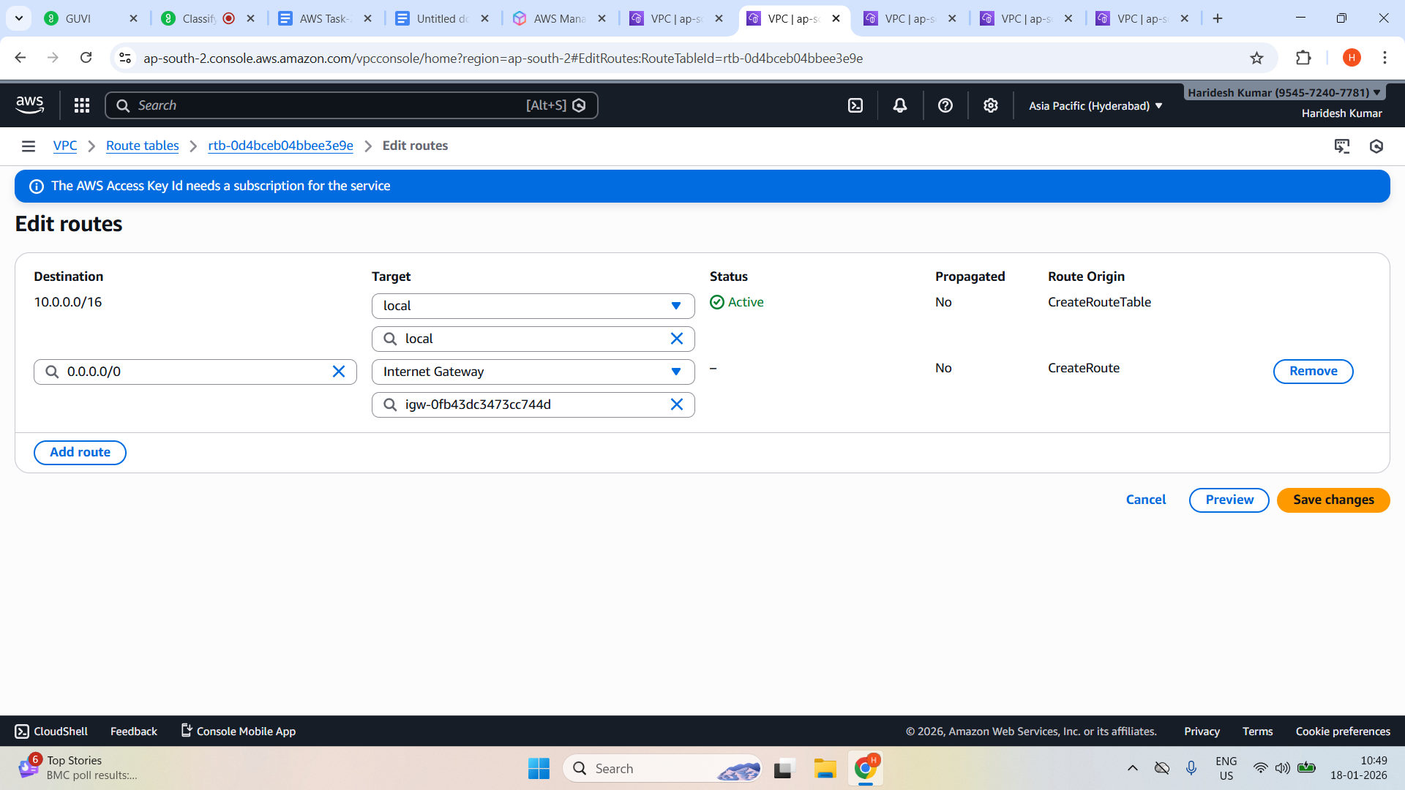

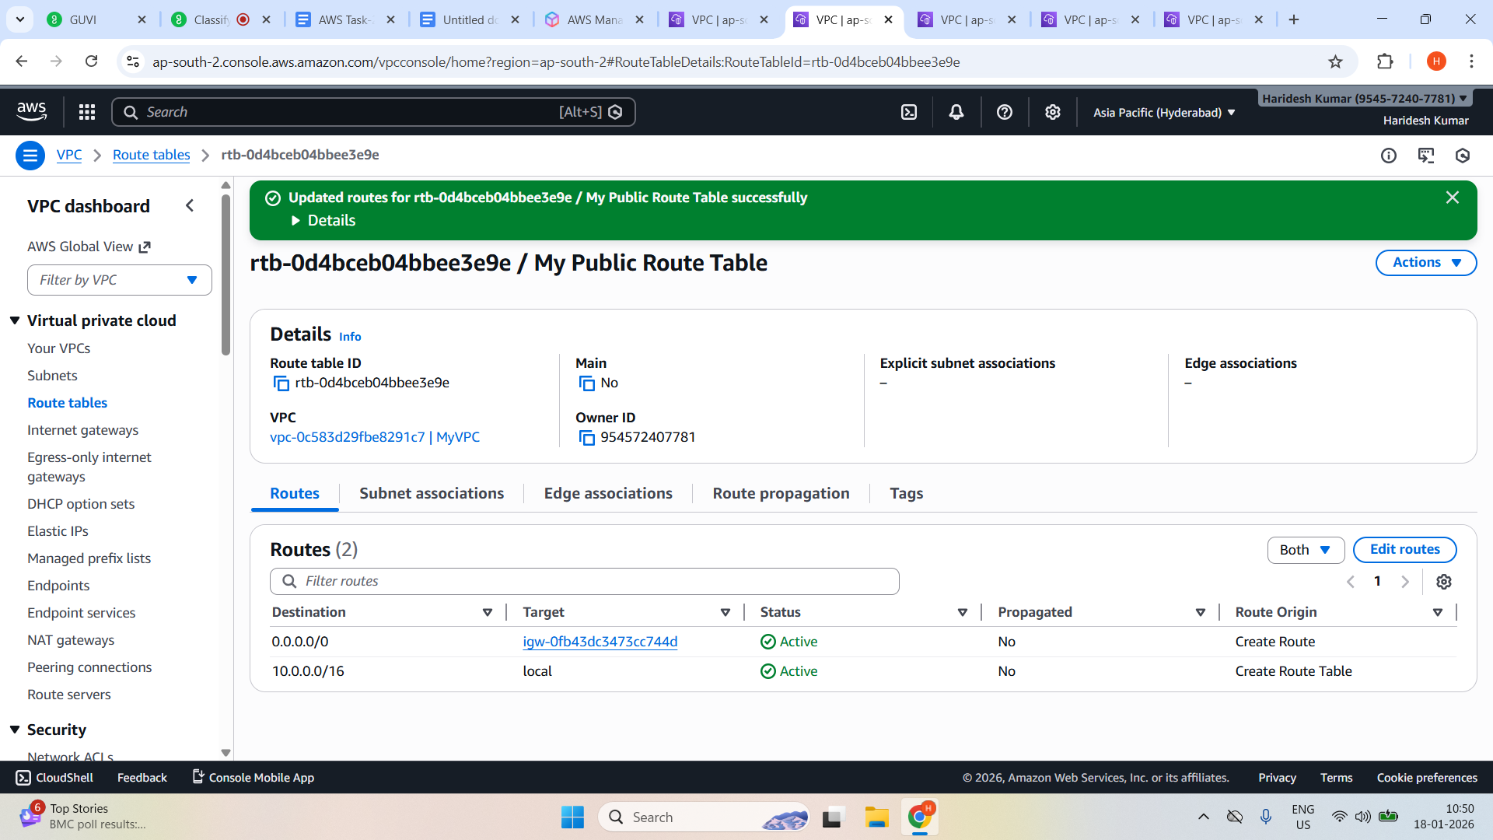

**Associate Route Table with Public Subnet**

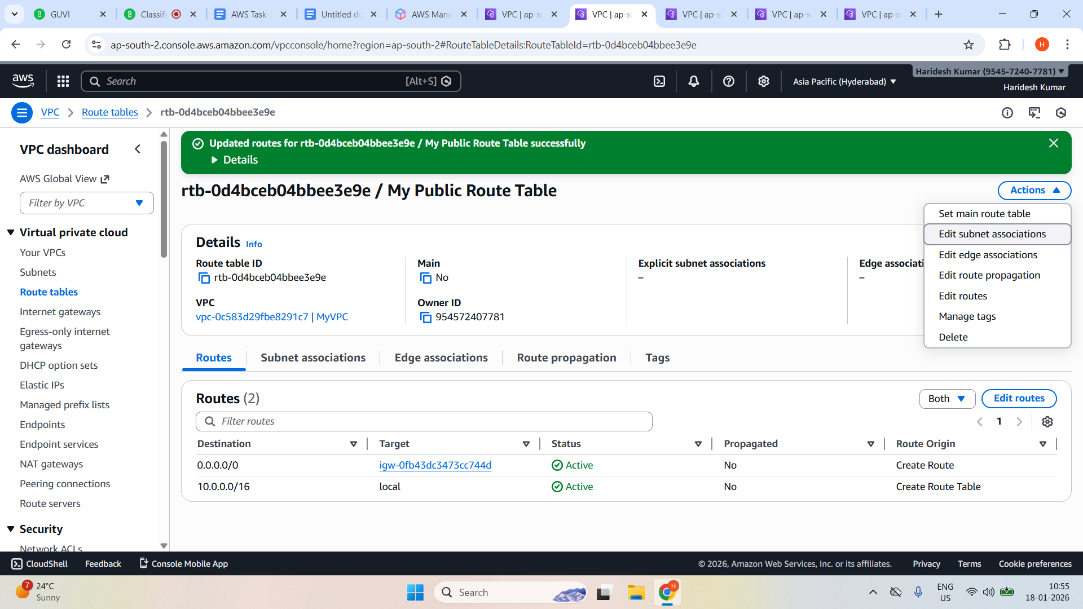

**Select public subnet and and save**

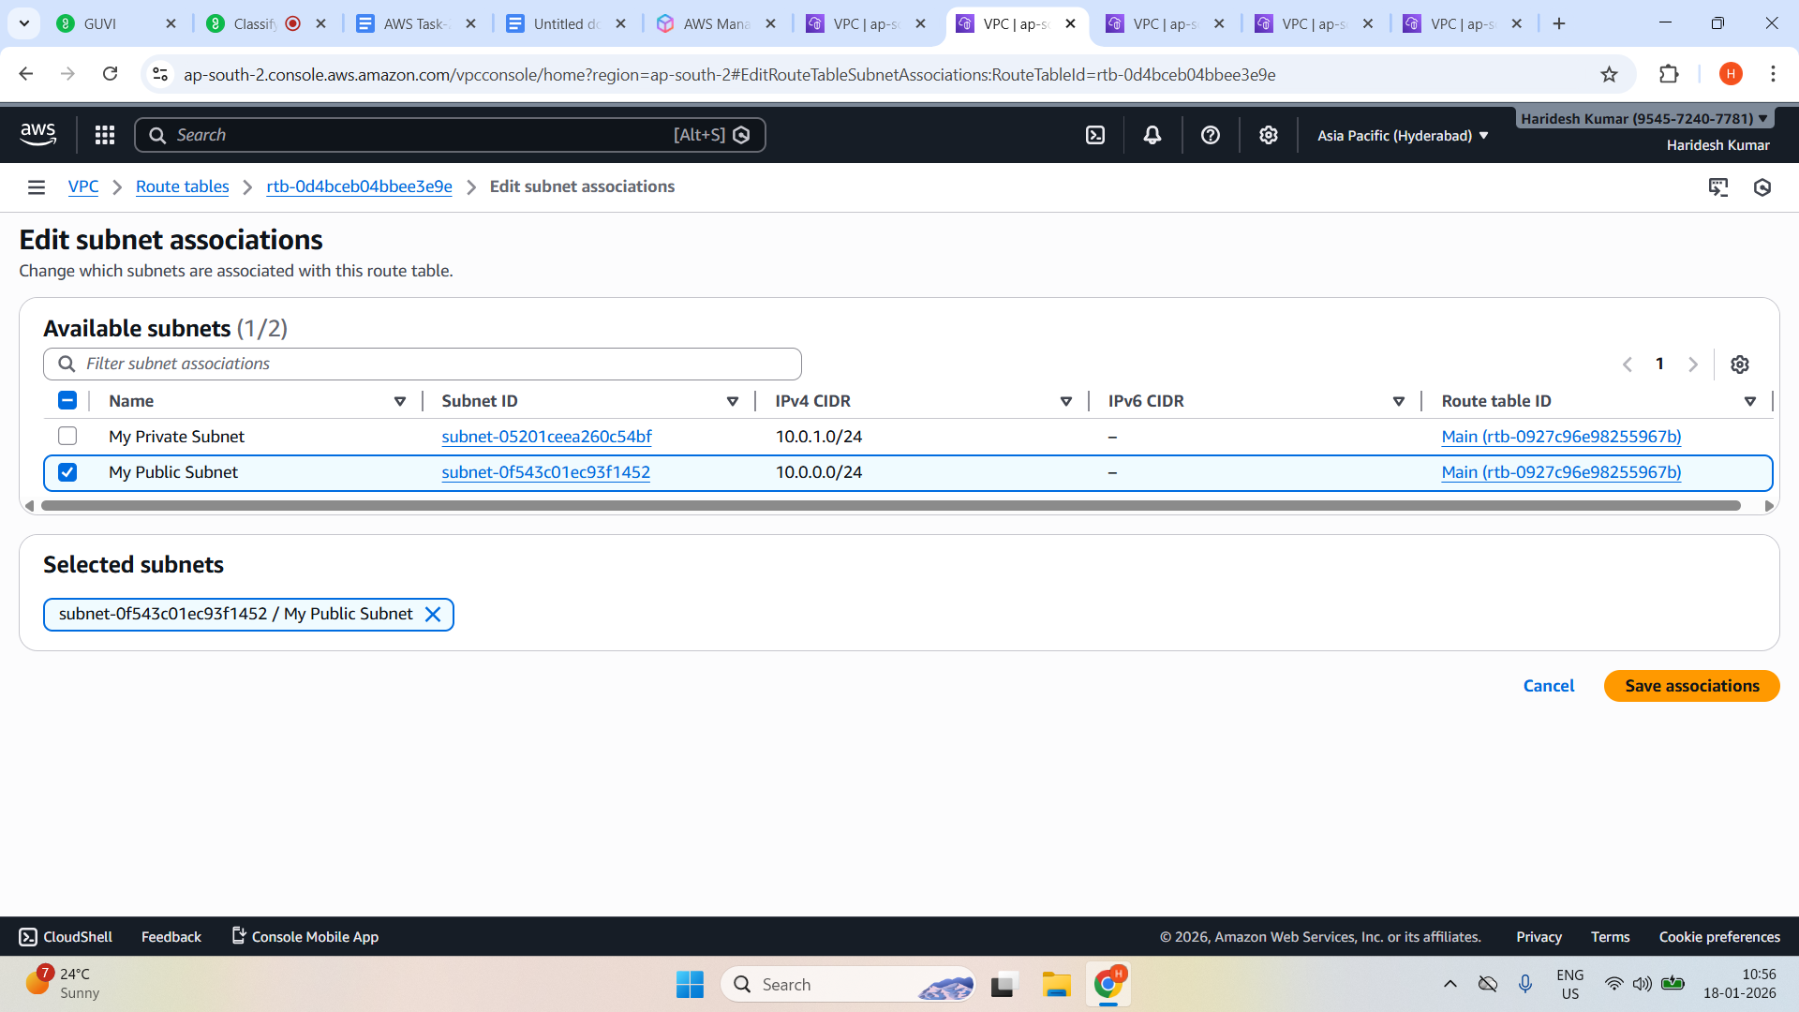

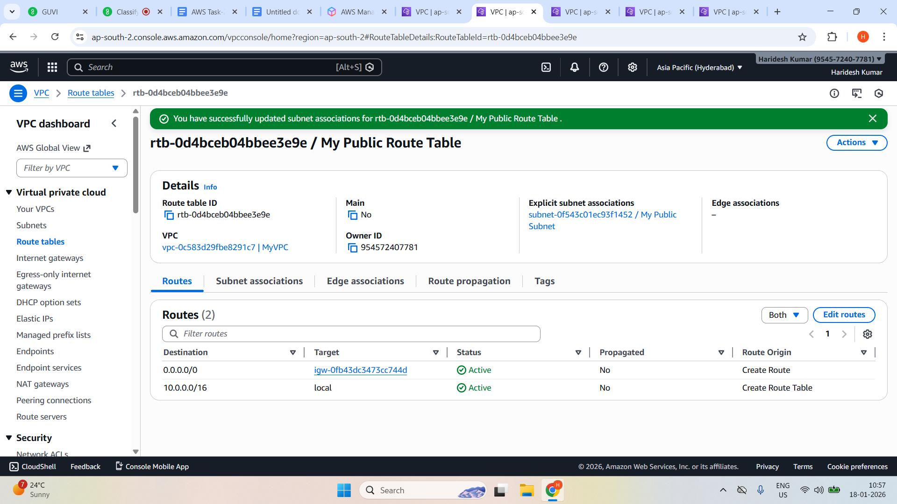

**Launch Linux EC2 Instance**

**Network settings info while creating EC2 instance**

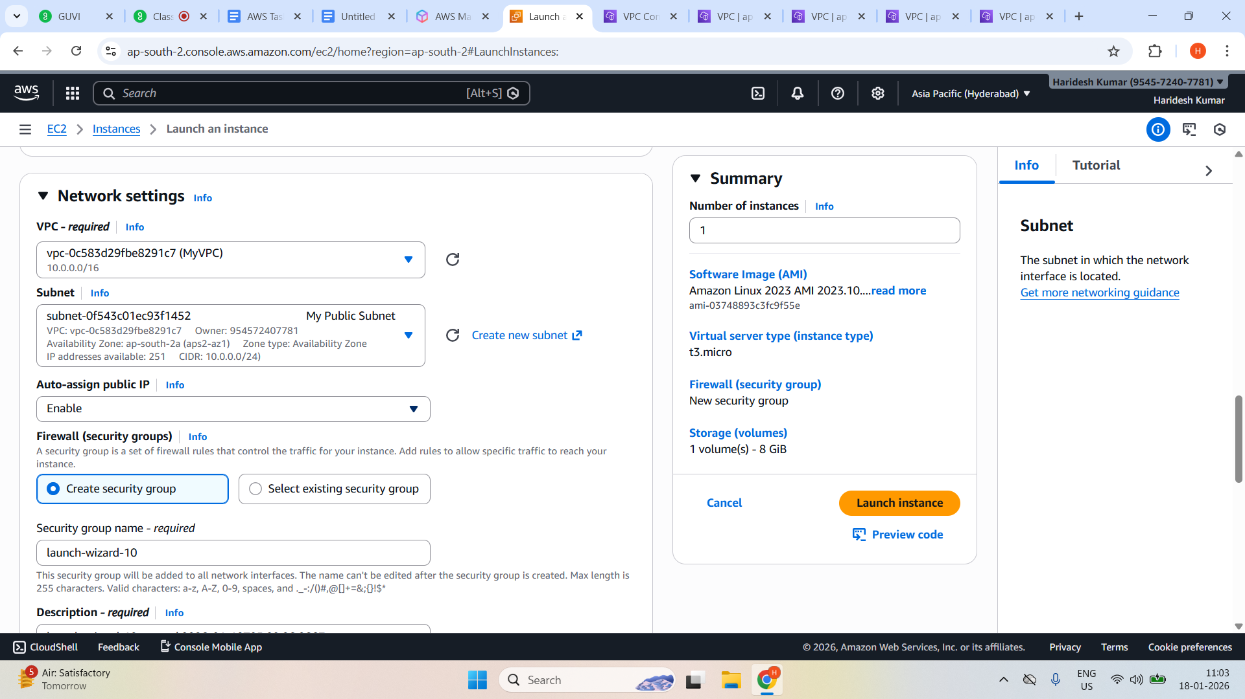

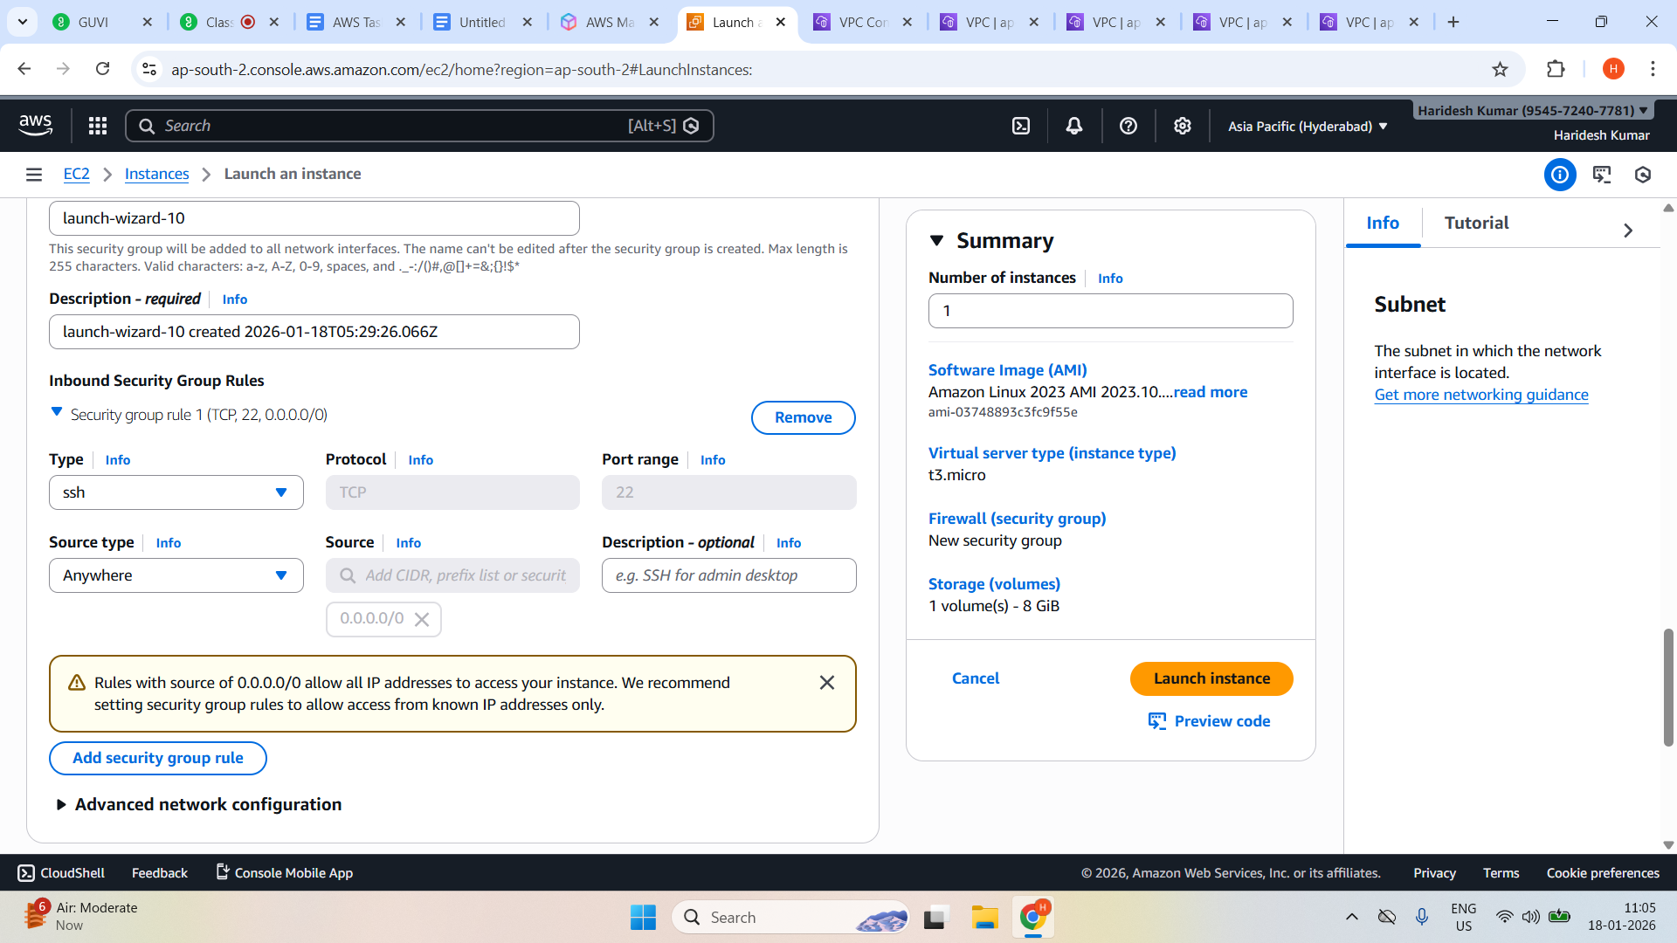

**Launched a Linux EC2 instance by using the above VPC and Public subnet.**

